 

Company number : **05539195 Redford & Co, 64 Baker Street, London, W1U 7GB**

**TURNER Imogen Sarah**

CONTRACT

# SUBJECT OF THE AGREEMENT

* 1. Pursuant to this Agreement:

Contractor - SMALL WORLD RECRUITMENT LIMITED

Company number 05539195 Redford & Co, 64 Baker Street, London, W1U 7GB. **Client:**

The Contractor personally, at its own risk, provides the Client with services listed in paragraph 1.2 of this Agreement (hereinafter referred to as "Services") within the period agreed by the Parties. The Client accepts the Services provided by the Contractor and pays for the Services within the time, manner, and amount established by this Agreement.

* 1. Services provided by the Contractor to the Client in accordance with paragraph 1.1 of this Agreement:
     1. Assistance in employment abroad.

# PROCEDURE FOR PERFORMANCE OF THE AGREEMENT

* 1. The Contractor collects the information required for the provision of Services through its independent search, selection, systematization, and analysis.

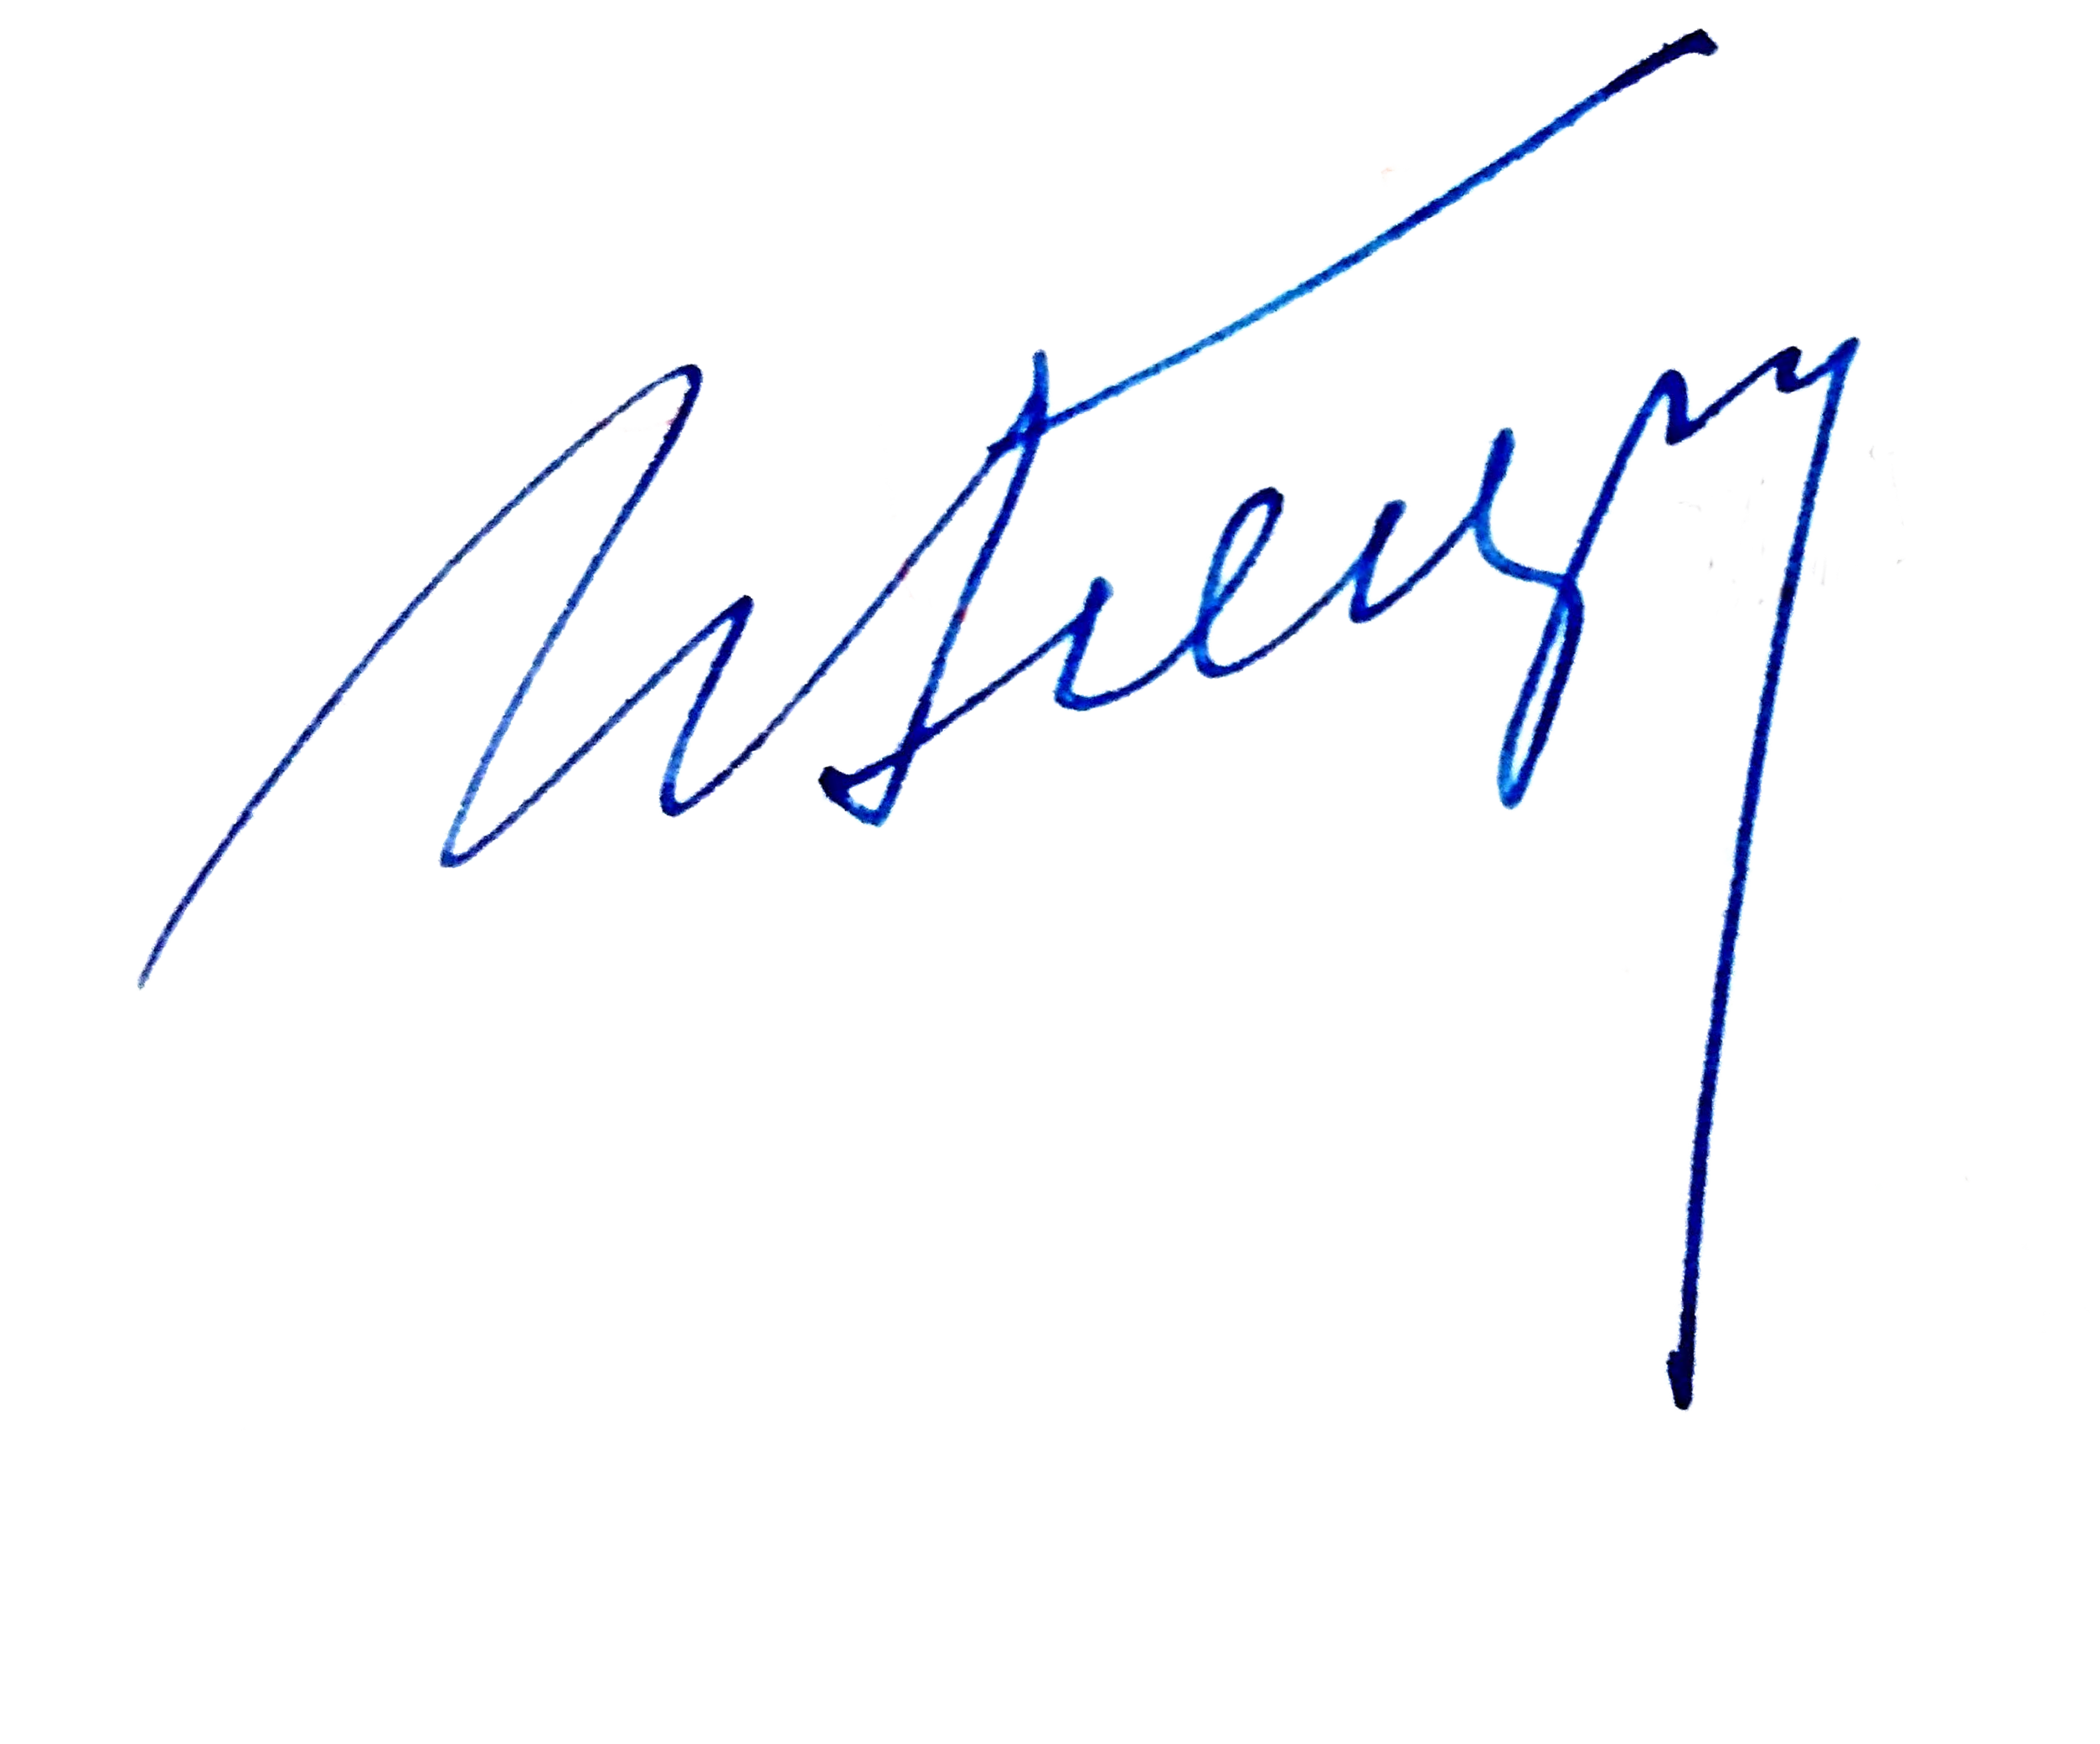

* 1. Services are provided solely based on the information and documentation to be provided by the Client at the request and discretion of the Contractor, in accordance with the Contractor's internal procedures.
  2. Term of providing Services:
     1. 30 (thirty) working days (excluding holidays or weekends) from the moment of payment in the amount and in the manner prescribed by paragraphs 4.1 and 4.2 of this Agreement.
  3. The Client agrees that proper quality and timely provision of Services are possible only if the Client fulfills all its obligations in good faith under this Agreement.
  4. The provision of Services ends, and this Agreement is terminated upon the full implementation of providing the Client with all searched, analyzed, and systematized information and documentation in accordance with the Client’s instructions.
  5. Information and documentation shall be transmitted by the Contractor to the Client in any way at the Contractor's choice, including orally, in paper form, by mail or courier, via telephone SMS, communication programs ("Viber", "WhatsApp", or "Telegram"), or e-mails.
  6. The transfer-acceptance of the provided Services may be formalized by an act of transfer- acceptance of services, signed by both Parties.
  7. If one Party refuses to sign the act of transfer and acceptance of services, the other Party may sign it unilaterally and indicate the refusal.
  8. The Contractor shall take action to perform this Agreement only after the Client has made payment in accordance with clauses 4.1 and 4.2.

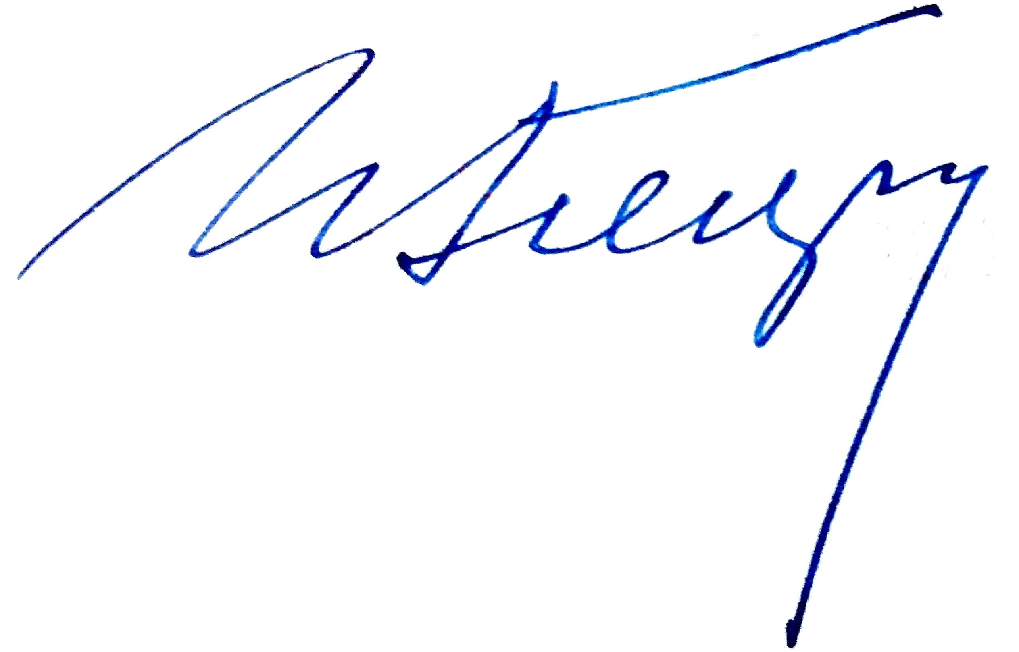

# RIGHTS AND OBLIGATIONS OF THE PARTIES

* 1. Client's Obligations:
     1. Provide complete and reliable information.
     2. Pay all costs independently, including postal and delivery services.
     3. Accept the provided Services in accordance with the terms.
     4. Pay for the provided Services as specified in this Agreement.
  2. Client's Rights:
     1. Require the provision of Services within the specified period and quality.
     2. With the Contractor's assistance, complete all required forms and documents.
     3. Follow the Contractor’s instructions for interviews and document preparation.
  3. Contractor's Obligations:
     1. Conduct searches, analyses, and provide Services independently and competently.
     2. Ensure a high professional level of Services.
     3. Inform the Client about any issues affecting the Services.
     4. Assist in document preparation and employer communication.
  4. Contractor's Rights:
     1. Choose information sources independently.
     2. Delegate tasks while maintaining responsibility for quality and deadlines.
     3. Adjust actions to serve the Client’s interests better.

# AMOUNTS AND PROCEDURE OF PAYMENT FOR PROVIDED SERVICES

* 1. For preparing a visa invitation, the Client shall pay the UK visas and immigration fee of

£250 per person.

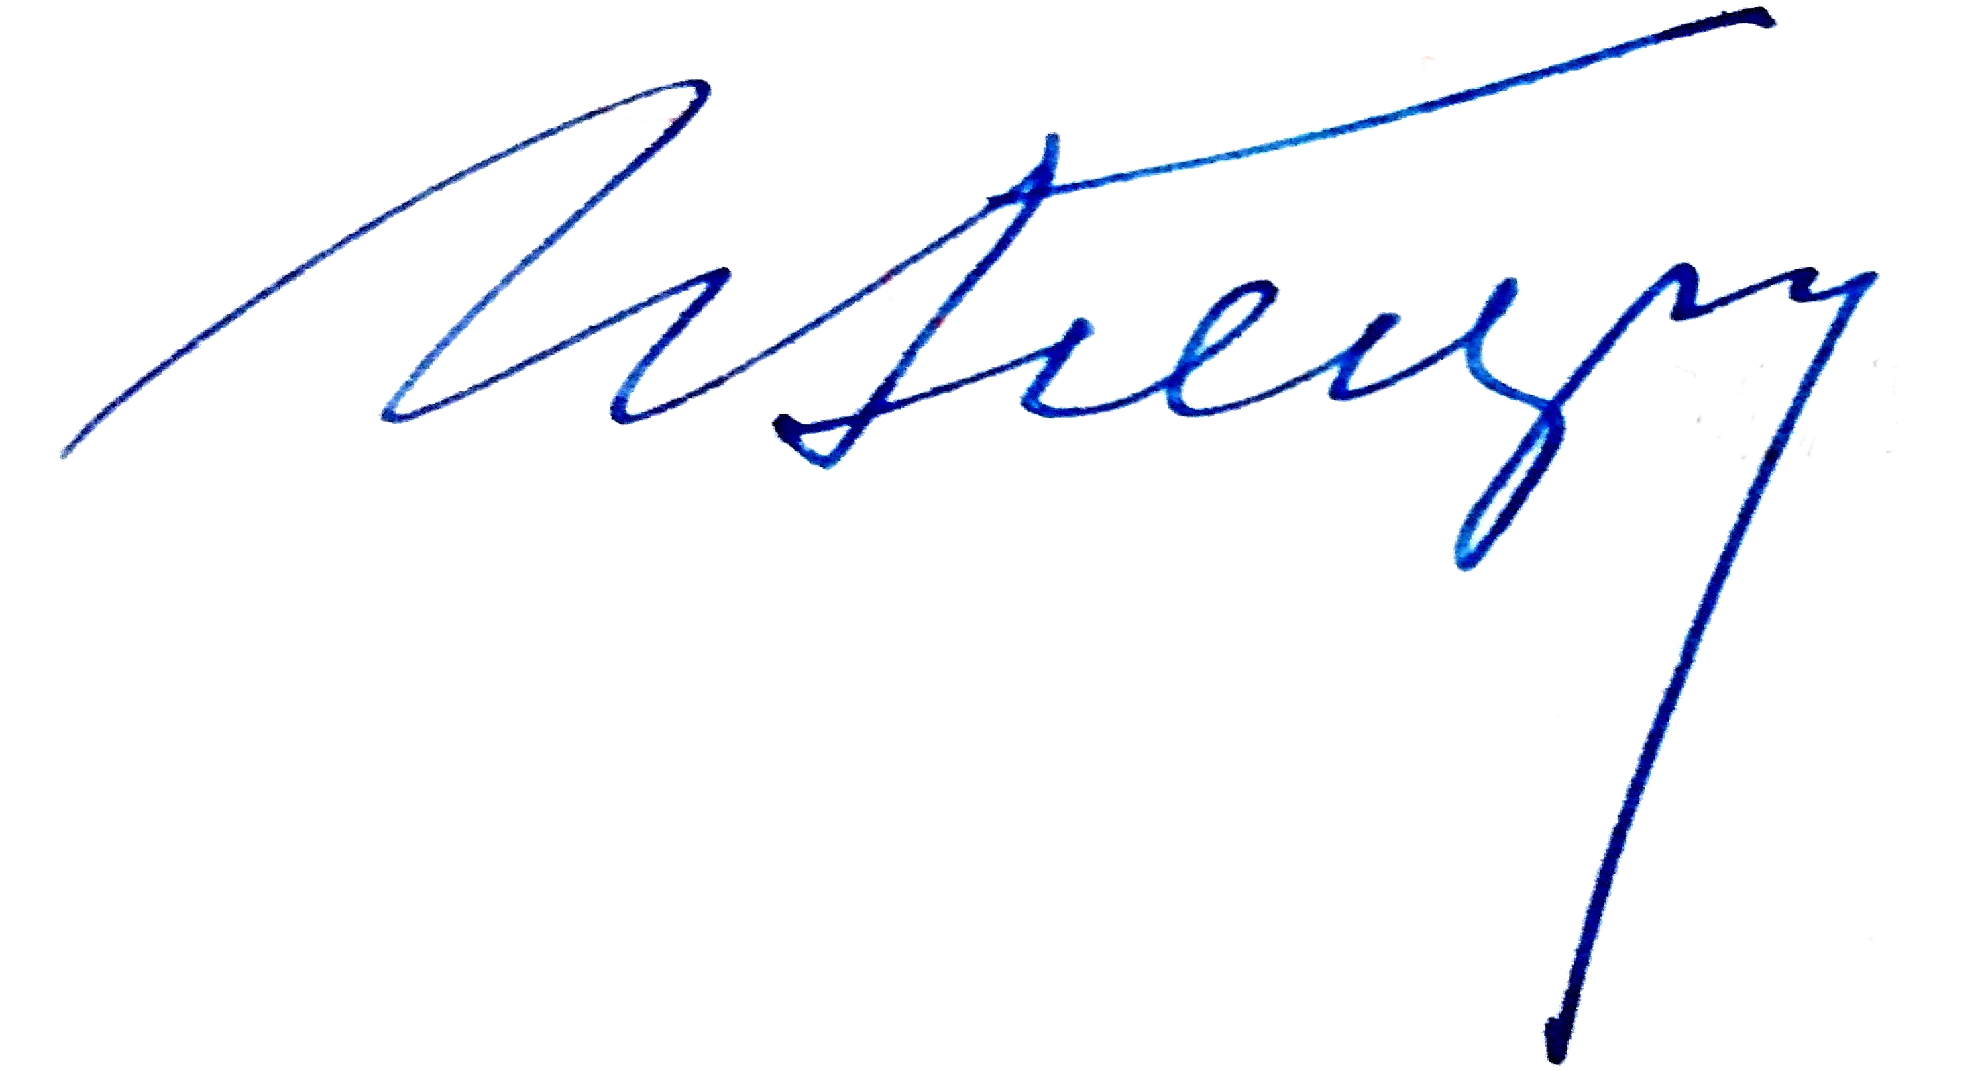

* + 1. Payment can be refunded if Services are not provided.
    2. All payments go exclusively to the UK visas and immigration.
    3. The Contractor is not permitted to charge additional service fees.
  1. Payment terms and procedures are independent of the employment contract’s conclusion, continuation, or termination.

# EXPIRY DATE, TERMINATION, AND TERMINATION OF THE AGREEMENT

* 1. This Agreement is effective upon signing by both Parties and remains so until all obligations are fulfilled.
  2. Termination may occur by mutual agreement or by the Contractor’s unilateral withdrawal in specific cases, such as non-payment or failure to provide necessary documentation by the Client.

# RESPONSIBILITY OF THE PARTIES AND DISPUTE RESOLUTION

* 1. Disputes shall be resolved under the laws of Great Britain.
  2. The Contractor guarantees the quality of Services but does not ensure employment.
  3. The Contractor is not liable for conditions beyond its control, including employer actions or consular decisions.

# ADDITIONAL CONDITIONS

* 1. This Agreement supersedes all prior oral or written agreements.
  2. Changes to this Agreement require mutual consent in writing.

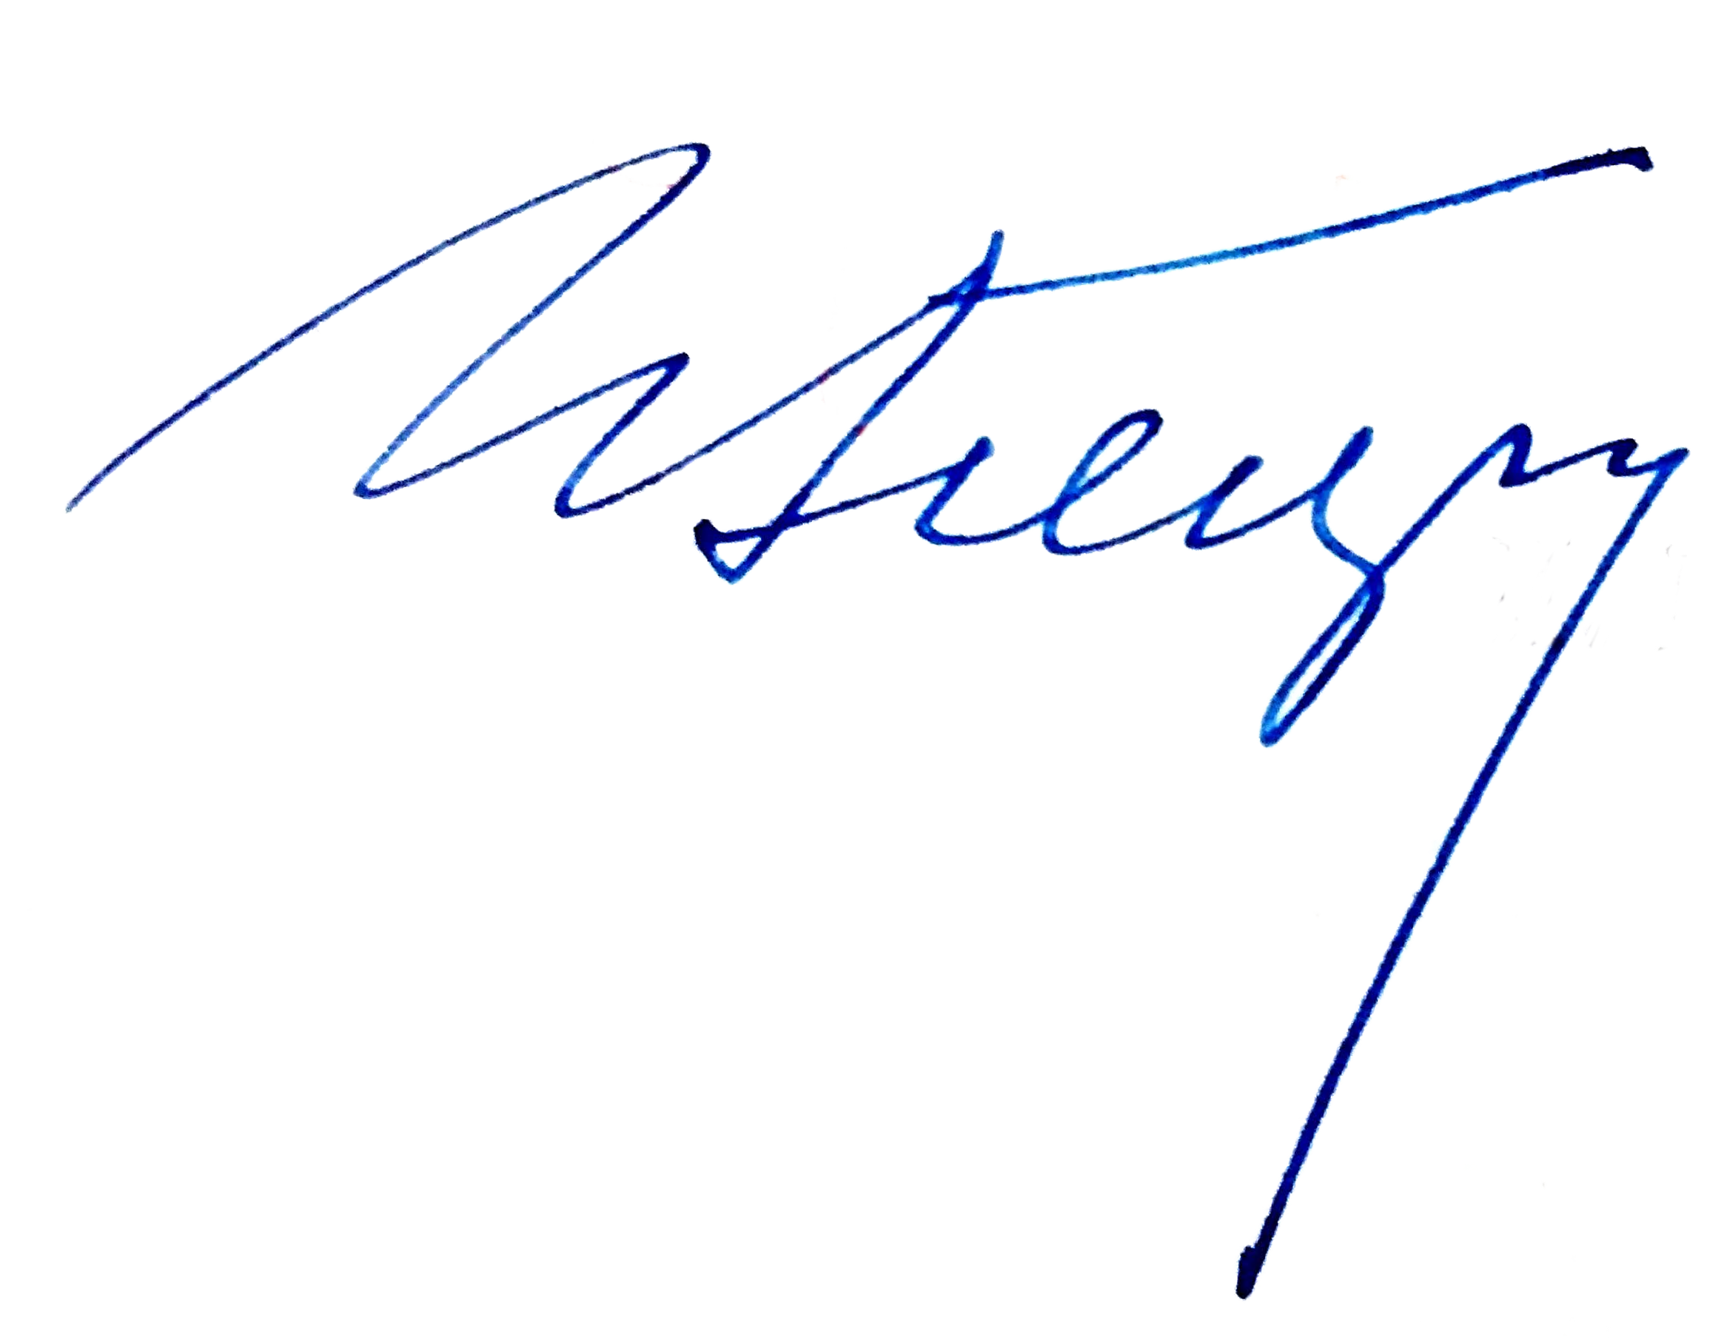

* 1. Both Parties confirm their legal capacity to enter into this Agreement.
  2. The Agreement’s electronic form holds the same legal effect as the original.
  3. Contact changes must be communicated promptly.

By signing this Agreement, the Client consents to personal data processing for the Contractor’s obligations under applicable laws of Great Britain.

Signatures:

Client

Date:

Contractor Date: